Arka Haldi
2018130014
5th October 2020

CEL 51, DCCN, Monsoon 2020
Lab 6: Subnet and Router Configuration

Topology Diagram

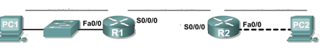
- Addressing Table
Device | Interface | IP Address | Subnet Mask | Default Gateway
R1 | Fa0/0 | 192.168.1.65 | 255.255.255.192 | N/A
R1 | S0/0/0 | 192.168.1.129 | 255.255.255.192 | N/A
R2 | Fa0/0 | 192.168.1.193 | 255.255.255.192 | N/A
R2 | S0/0/0 | 192.168.1.190 | 255.255.255.192 | N/A
PC1 | NIC | 192.168.1.126 | 255.255.255.192 | 192.168.1.65
PC2 | NIC | 192.168.1.254 | 255.255.255.192 | 192.168.1.193

Learning Objectives
Upon completion of this lab, you will be able to:
- Subnet an address space given requirements.
- Assign appropriate addresses to interfaces and document.
- Configure and activate Serial and FastEthernet interfaces.
- Test and verify configurations.
- Reflect upon and document the network implementation.

Scenario
In this lab activity, you will design and apply an IP addressing scheme for the topology shown in the Topology Diagram. You will be given one address block that you must subnet to provide a logical addressing scheme for the network. The routers will then be ready for interface address configuration according to your IP addressing scheme. When the configuration is complete, verify that the network is working properly.
Task 1: Subnet the Address Space.
Step 1: Examine the network requirements.
You have been given the 192.168.1.0/24 address space to use in your network design. The network consists of the following segments:
- The network connected to router R1 will require enough IP addresses to support 15 hosts.
- The network connected to router R2 will require enough IP addresses to support 30 hosts.
- The link between router R1 and router R2 will require IP addresses at each end of the link.
Step 2: Consider the following questions when creating your network design.
Q. How many subnets are needed for this network?
2 subnets are needed to meet the demand for the 15 and 30 hosts on each of the networks, we need another subnet so that we can connect both the subnets with a route that is not belonging to either so that the link shares the same NID.
So, we need total of 3 subnets

Q. What is the subnet mask for this network in dotted decimal format?
CIDR of the assigned network is 24 ,
We are free to use 2⁸ addresses, we divide the network into 4(2²) subnets and use 3 of the 4 assigned subnet divisions,
Hence now we have 64 (2⁶) addresses under each subnet, which can be assigned to the networks.
That translates to the last 6 bits, and reserves the rest 26 bits as NID.
CIDR : 26
Subnet mask : 11111111. 11111111. 11111111. 11000000
Subnet mask : 255.255.255.192

Q. What is the subnet mask for the network in slash format?
Subnet mask in slash format is /26

Q. How many usable hosts are there per subnet?
Usable hosts per subnet : 64 – 1 – 1 = 62 hosts (first and last addresses are reserved for identification and broadcasting respectively)
Step 3: Assign sub-network addresses to the Topology Diagram.
- Assign subnet 1 to the network attached to R1.
Since the first subnet is reserved, we can assign the subnet 192.168.1.64/26 to R1
- Assign subnet 2 to the link between R1 and R2.
We can assign the subnet 192.168.1.128/26 to link between R1 & R2
- Assign subnet 3 to the network attached to R2.
We can assign the subnet 192.168.1.192/26 to R3

- According to the ranges above we assign the IP addresses as below:
Device | Interface | IP Address | Subnet Mask | Default Gateway
R1 | Fa0/0 | 192.168.1.65 | 255.255.255.192 | N/A
R1 | S0/0/0 | 192.168.1.129 | 255.255.255.192 | N/A
R2 | Fa0/0 | 192.168.1.193 | 255.255.255.192 | N/A
R2 | S0/0/0 | 192.168.1.190 | 255.255.255.192 | N/A
PC1 | NIC | 192.168.1.126 | 255.255.255.192 | 192.168.1.65
PC2 | NIC | 192.168.1.254 | 255.255.255.192 | 192.168.1.193
Task 2: Determine Interface Addresses.
Step 1: Assign appropriate addresses to the device interfaces.
- Assign the first valid host address in subnet 1 to the LAN interface on R1.
192.168.1.65
- Assign the last valid host address in subnet 1 to PC1.
192.168.1.126
- Assign the first valid host address in subnet 2 to the WAN interface on R1.
192.168.1.129
- Assign the last valid host address in subnet 2 to the WAN interface on R2.
192.168.1.190
- Assign the first valid host address in subnet 3 to the LAN interface of R2.
192.168.1.193
- Assign the last valid host address in subnet 3 to PC2.
192.168.1.254

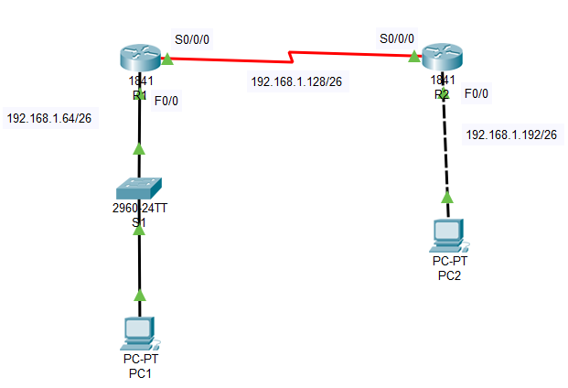
Task 3: Configure the Serial and FastEthernet Addresses.
Step 1: Configure the router interfaces.
Configure the interfaces on the R1 and R2 routers with the IP addresses from your network design. Please note, to complete the activity in Packet Tracer you will be using the Config Tab. When you have finished, be sure to save the running configuration to the NVRAM of the router.

R1 config
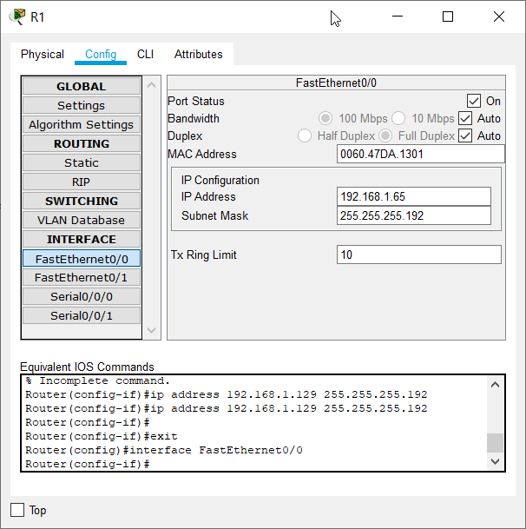
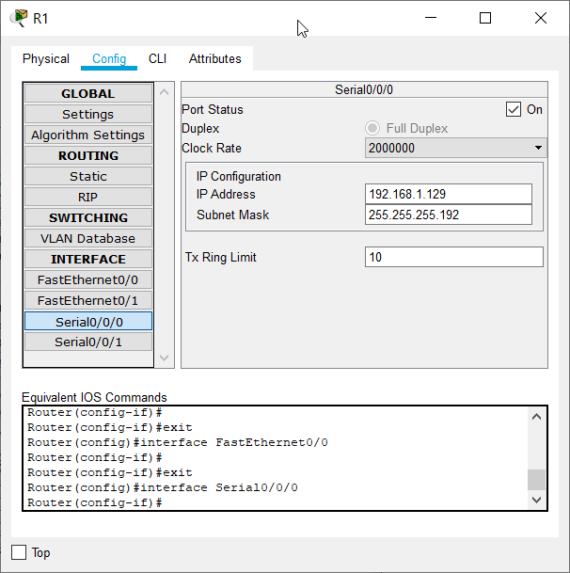

R2 config
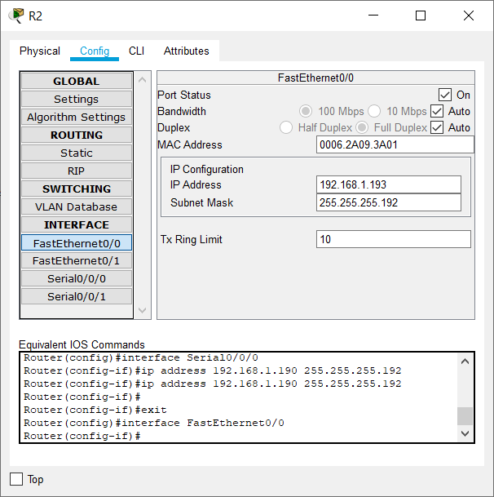
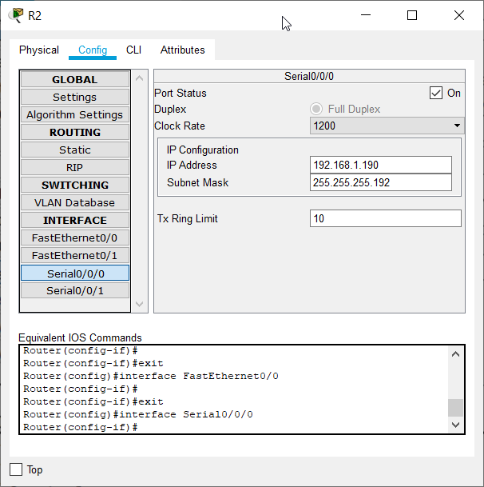

Step 2: Configure the PC interfaces.
Configure the Ethernet interfaces of PC1 and PC2 with the IP addresses and default gateways from your network design.
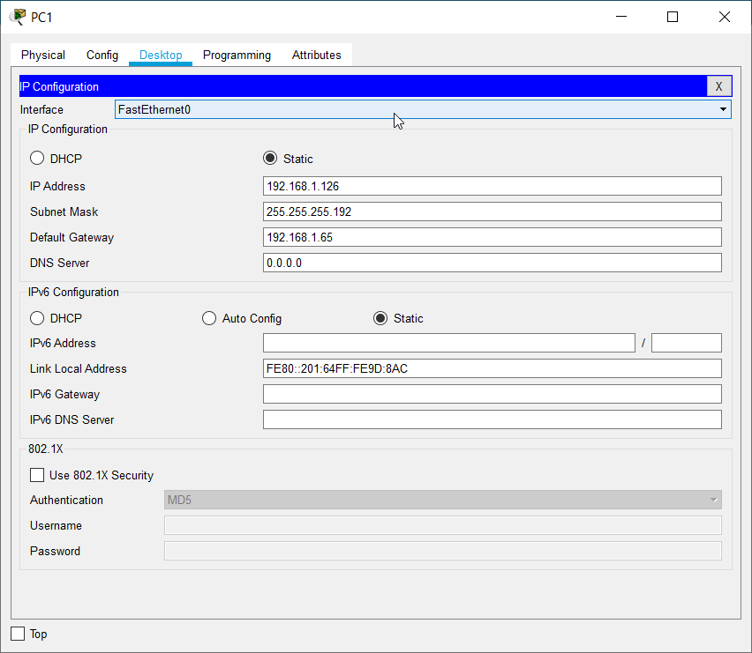
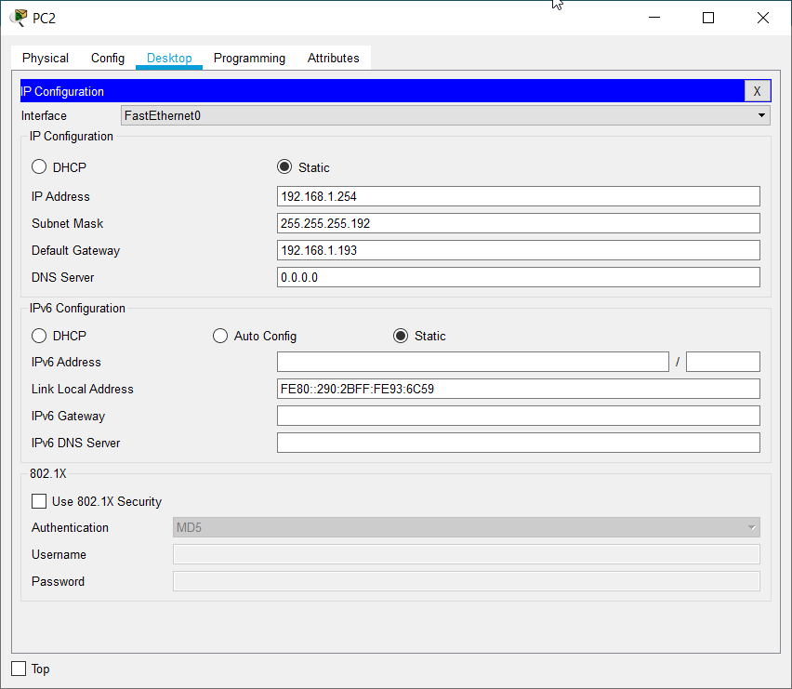
Task 4: Verify the Configurations.
Answer the following questions to verify that the network is operating as expected.
Q. From the host attached to R1, is it possible to ping the default gateway?
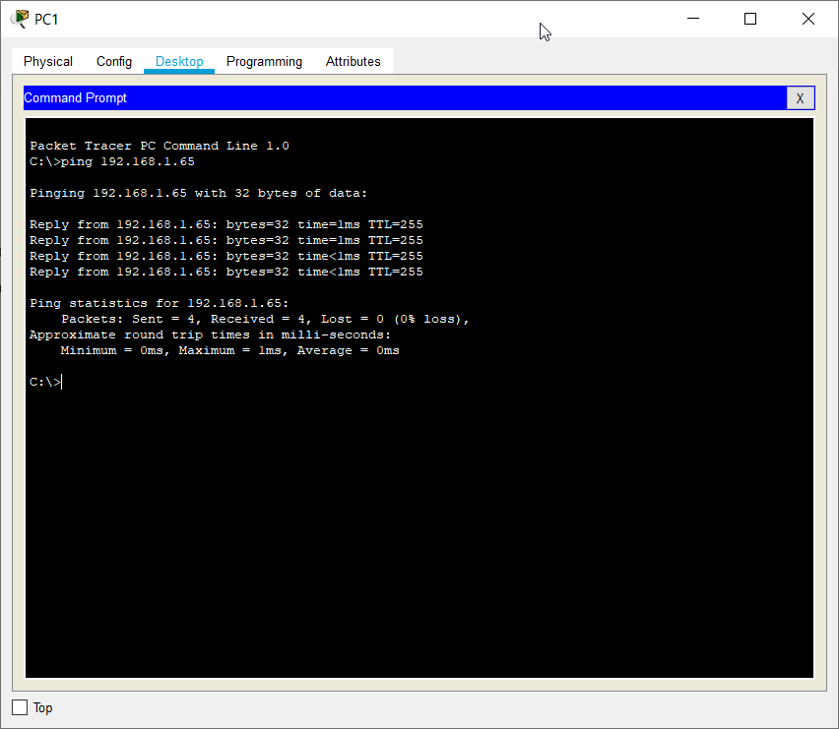
Yes
Q. From the host attached to R2, is it possible to ping the default gateway?
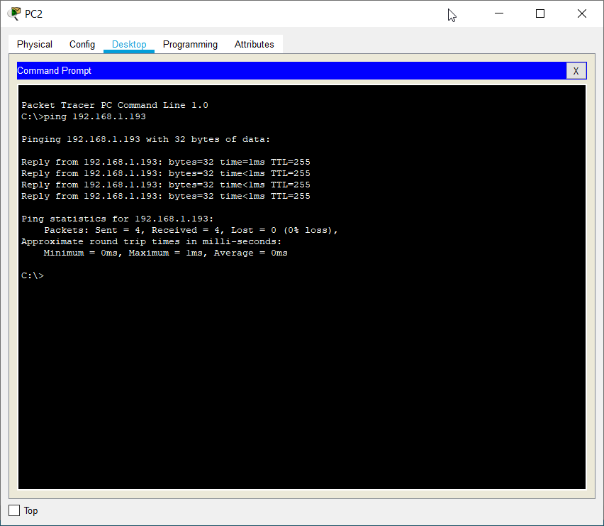
Yes
Q. From the router R1, is it possible to ping the Serial 0/0/0 interface of R2?
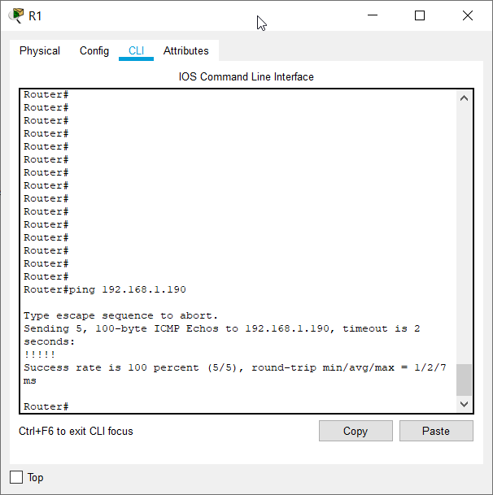
Yes
Q. From the router R2, is it possible to ping the Serial 0/0/0 interface of R1?
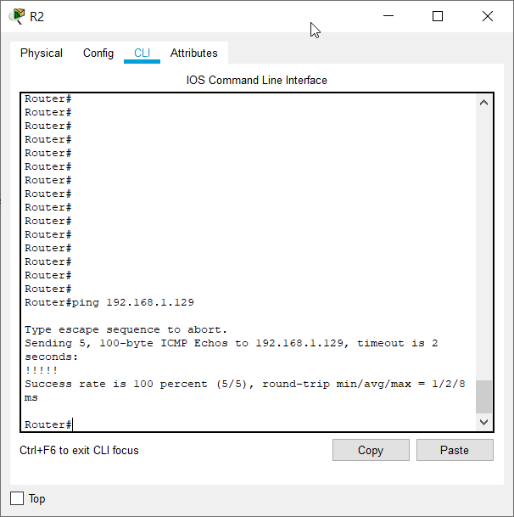
Yes
Task 5: Reflection
Are there any devices on the network that cannot ping each other?
Yes,
PC1 has access to Router1, and can ping the F0/0 of R1, and S0/0/0 of the router, however, it can’t ping the S0/0/0 of R2 or ping beyond it’s own subnet.
Similarly PC2, can maximum ping till S0/0/0 of R2, and not beyond, i.e PC1 can’t ping PC-2 and vice versa.
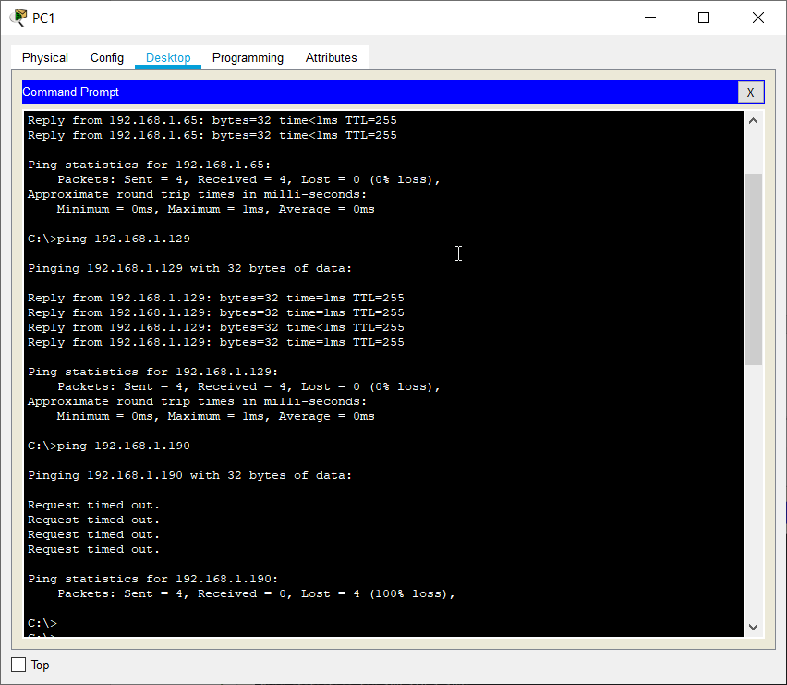
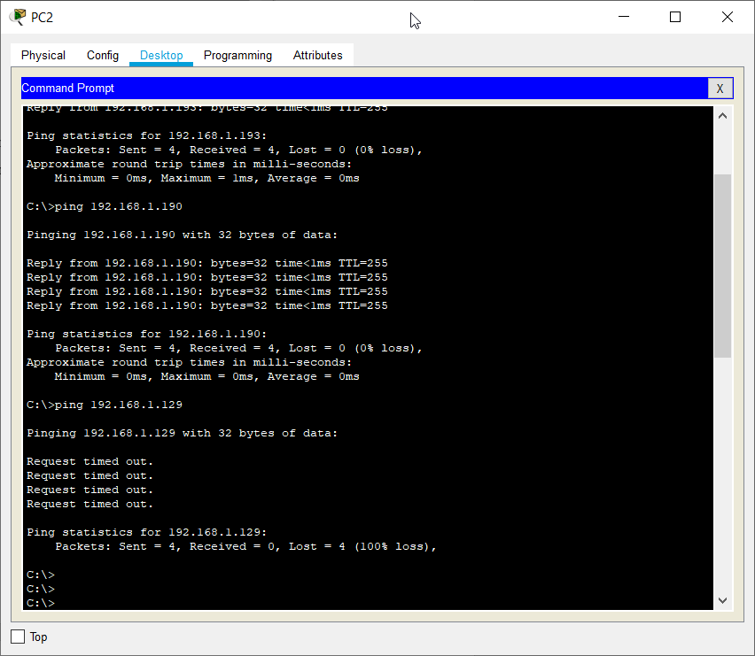

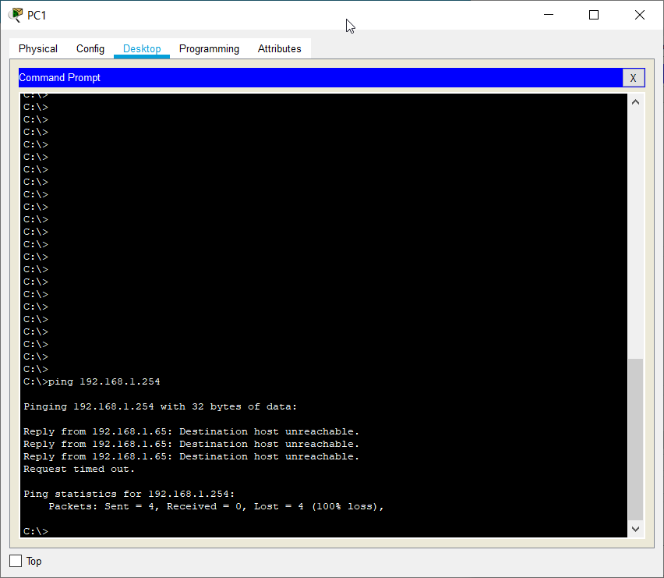
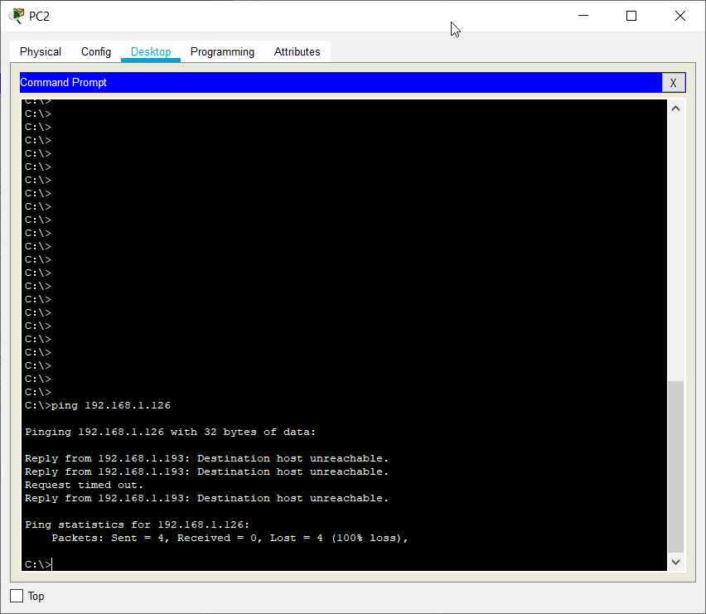
Q. What is missing from the network that is preventing communication between these devices?
These are the ARP tables for the two Routers :
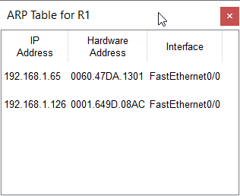
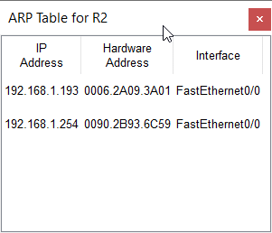
The Routers connecting the two LANs only have the IP addresses of the devices they have been configured to. Thus if we want the devices on the different LANs to be able to ping each other we need to configure the IP addresses of the devices on the Proxy Router ARP table.
But, central reason is cause of different NID’s and absence of a static route configuration among the two PC hosts

Conclusion :
We learnt how to choose and set up subnets, how masking works in serverless routing, and also how to debug such networks briefly.

